Using the Snellen chart provided, sitting 6 meters (or 20 feet) away, for each eye note the smallest line which you can accurately see. Measure the size of the letters on this line with a ruler. Using the visual angle equation in the figure and the equation for visual acuity, calculate the visual acuity for each of your eyes[4].

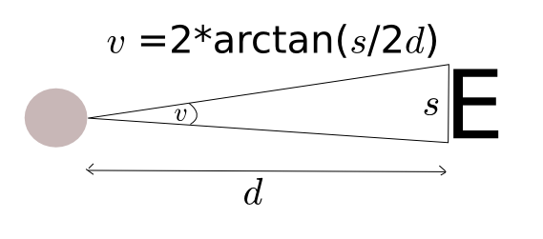
Visual acuity = Distance at which test is made / distance at which the smallest letters identified subtends an angle of 5 arcminutes

Hints: 1 arcminute = 1/60 of a degree , 1 metre = 3.28 feet.

Answer for smallest letter size visible = 8mm

[1] Rearrange visual angle equation: d = s / (2 * tan(v/2))

[1] With s = 8mm, v = 5/60 degrees → d= 5.5 metres

[1] Therefore Visual acuity = 6/5.5 or 20/18

[1] Units are correct

